CT6576:

Species: Human (female, 84 Yr-old, weight and height not available)

Imaging: multi-slice CT imaging of the head and torso (623-μm isotropic resolution, FOV 31.9 × 31.9 × 46.1 cm, i.e., image volume size of 512 × 512 × 739).

Segmentation: based on intensity thresholding followed by visual validation and repair.

Model: upper airways (nasal passages or oral cavity, both available) down to several generations of conducting airways (9 ± 2 airway generations, 135 outlets). A cylinder capturing the contours of the face and extending several centimeters away from the face is included with the distal end of the cylinder used to initiate airflows and chemical exposures.

Mesh: polyhedral mesh created in OpenFOAM

Simulation types: airflow, vapor exposure

Funding: NHLBI R01 HL073598 and NIEHS P01 ES011617

Related publications: Corley et al., 2012 (<https://doi.org/10.1093/toxsci/kfs168>); Corley et al., 2015 (<https://doi.org/10.1093/toxsci/kfv071>)

PDO1 (Kabilan et al., 2016):

Human (male, 35 Yr-old, 68 kg, 1.70 m tall)

Imaging: multi-slice CT imaging of the head and torso (0.5 x 0.7 x 0.7 mm resolution, FOV 36 × 36 × 48 cm, i.e., image volume size of 512 × 512 × 960).

Segmentation: based on intensity thresholding followed by visual validation and repair. Larynx was widened from the as-imaged supine breath-hold position to a fully open geometry to mimic inhalation in an upright posture.

Model: Nose down to several generations of conducting airways (272 outlets). Model is provided in 5 stl files as listed in the figure.

Mesh: Hybrid prism/polyhedral volume meshes generated in STARCCM+ (Version 8.02, 5,751,626 nodes and 2,550,285 polyhedral elements)

Simulation types: airflow and aerosol transport

Funding: NHLBI R01HL073598

Related publications: Kabilan et al., 2016 (<https://doi.org/10.1016/j.jaerosci.2016.01.011>)

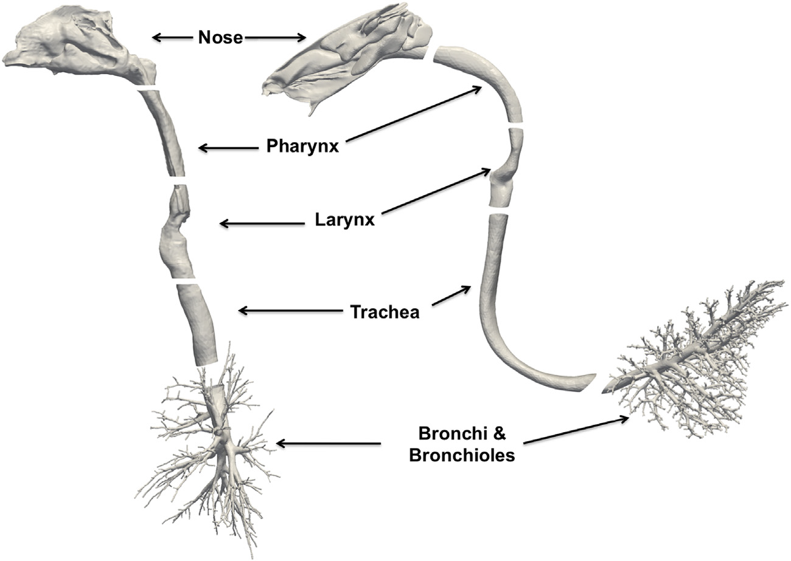

PDO1 (Corley et al., 2021):

Human (male, 35 Yr-old, 68 kg, 1.70 m tall)

Imaging: multi-slice CT imaging of the head and torso (0.5 x 0.7 x 0.7 mm resolution, FOV 36 × 36 × 48 cm, i.e., image volume size of 512 × 512 × 960).

Segmentation: based on intensity thresholding followed by visual validation and repair. In Kabilan et al’s study (2016), the larynx was widened from the as-imaged supine breath-hold position to a fully open geometry to mimic inhalation in an upright posture. Additional modifications of the oral cavity, i.e., repositioning surface of the tongue for upright oral breathing and closing off the connection to the esophagus, were made in the model used in Corley et al.’s study (2021).

Models: 1) Oral cavity down to several generations of conducting airways (272 outlets). Model is provided in 5 stl files; 2) Nose down to trachea. Model is provided in 4 stl files.

Mesh: Hybrid prism/polyhedral volume meshes generated in STARCCM+ (Version 8.02 for the nasal breathing model (2.85 million elements) and version 14.04.011 for the oral breathing model (4.88 million elements)). Detailed computational mesh characteristics can be found in Table 1 of Corley et al (2021)

Simulation types: airflow and aerosol transport

Funding: NHLBI R01HL073598 and NIEHS U01 ES028669

Related publications: Corley et al., 2021 (<https://doi.org/10.1093/toxsci/kfab062>)

Twin 1-18425 (Corley et al., 2015)

Human (male, 18 Yr-old, 72 kg, x.xxm tall)

Imaging: multi-slice CT imaging of the head and torso (623-μm isotropic resolution, FOV 31.9 × 31.9 × 46.1 cm, i.e., image volume size of 512 × 512 × 739). Note: Copied from 80year old female, need to check if it is correct

Segmentation: based on intensity thresholding followed by visual validation and repair.

Model: Oral cavity down to several generations of conducting airways (8 ± 4 airway generations, 117 outlets). A cylinder capturing the contours of the face and extending several centimeters away from the face is included with the distal end of the cylinder used to initiate airflows and chemical exposures.

Mesh: polyhedral mesh created in OpenFOAM (782,000 elements, 442,000 nodes, and 181,000 surface facets, each with their anatomically defined PBPK model boundary condition)

Simulation types: airflow, vapor exposure

Funding: NHLBI R01 HL073598

Related publications: Corley et al., 2015 (<https://doi.org/10.1093/toxsci/kfv071>)

